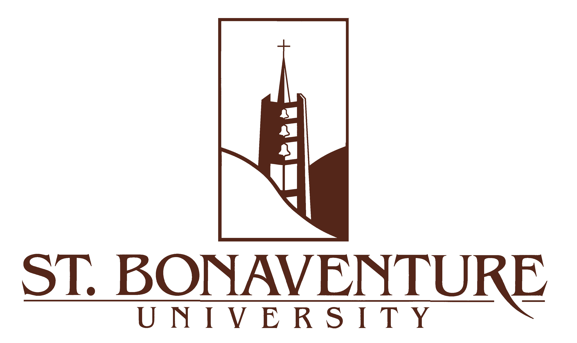

To Whom It May Concern:
I am very pleased to recommend Michael Loffredo for a position with your organization. I have known Michael since his arrival at St. Bonaventure in 2011. As his academic adviser and a faculty member who has had him in class more than once, I have been able to see him in a variety of situations over his college career. Because of the close relationship we in the Jandoli School encourage between students and their advisers, I have been able to talk often with Michael during that time.

Through his college career, Michael has reached for opportunities to develop his skills, especially in the area of sports communications. He served as a paid intern for the Buffalo Bills during the 2013 season; from conversations with him, I understand that the Bills gave him opportunities to see and be involved in a variety of the communications duties typical of an NFL team. Earlier, he had the chance to intern with the Buffalo Bisons baseball team, handling a number of game-day operations for the AAA team. He has also worked with our SBU-TV sports production crew, handling live broadcasts of home sporting events. Added to those experiences are the people skills Michael has developed through communications and non-communications jobs.

Michael's classroom experiences reinforce his practical work in broadcasting and marketing. In addition, as with all our graduates, Michael has gone through a program which emphasizes writing skills from the first semester a student is with us.

If you would like to talk with me further about Michael, please call 716-375-4042 or email me at cmcnall@sbu.edu.

Sincerely,

Carole McNall, J.D.
Assistant Professor

